COM 757: Artificial Intelligence - Coursework Task 1
Topic: Venue-Aware AI Assistant for Live Sound Mixing

Student Name: [User Name]
Student ID: [User ID]
Module Leader: [Module Leader Name]
Submission Date: January 07, 2026
Word Count: Approximately 2000 words

1. Introduction
Achieving optimal sound quality in dynamic venues is a major challenge for sound engineers. Real-time mixing imposes a high cognitive load, often leading to reactive adjustments. This report proposes a Venue-Aware AI Assistant (VAAA) that uses AI to analyze acoustic data and automate mixing tasks. We define the problem, review relevant research, present the VAAA design, and discuss its ethical implications.

2. Problem Context

2.1 Domain Definition and Specific Problem
Live sound engineering involves real-time audio reinforcement for events. The core problem is maintaining consistent audio in dynamic, unpredictable venues. Engineers manually balance sources using consoles like the Behringer X32, but fluctuating acoustics—driven by audience movement and environmental changes—complicate this. Limited by a single listening position and cognitive capacity, engineers often adopt a reactive approach, creating a bottleneck for optimal sound quality.

2.2 Importance and Evidence
Audio quality is vital for audience experience and event success. Poor sound detracts from performances and harms reputation. Compton (2024) shows that engineers face significant cognitive pressures, affecting their mix choices and audience well-being [1]. Studies also reveal a disconnect between produced sound levels and audience preferences, with many finding events too loud [1]. This indicates that manual mixing often fails to meet expectations, making AI-driven optimization a critical industry need.

2.3 Opportunities and Risks of AI in the Domain
AI offers proactive acoustic adaptation, consistency across venues, and reduced cognitive load for engineers. However, risks include sterile sound lacking human nuance, technical failure/latency during live shows, and cultural biases in mixing styles if trained on non-diverse data.

3. Critical Review of Research

3.1 Review Method / Search Strategy
A systematic search was conducted across IEEE Xplore, ACM, and SpringerLink using keywords like "AI audio engineering" and "live sound reinforcement." Inclusion criteria focused on peer-reviewed papers from the last decade addressing real-time audio systems. Literature was grouped by thematic approaches for comparative analysis.

3.2 Thematic Comparison of AI Approaches
AI in audio engineering includes rule-based systems and deep learning (DL). Fermin (2020) used fuzzy logic for multitrack mixing, but such systems struggle with the unpredictable nature of live sound [7]. Conversely, DL models like CNNs and RNNs excel at pattern recognition. Moysis et al. (2023) and Gul and Khan (2023) highlight DL's success in source separation and audio enhancement [10] [6]. However, DL requires massive datasets and lacks interpretability. Supervised learning is common, as seen in Koszewski’s (2023) CNN-based studio mixer, but real-time live data is scarce and subjective, limiting its direct application [3].

3.3 Gaps and Opportunities
A critical gap exists: the lack of venue-aware, real-time AI systems. Current solutions by Koszewski (2023) and Terrell and Sandler (2012) focus on offline studio mixing or isolated tasks [3] [2]. While Fernandez et al. (2025) simulate acoustics, they do not control physical mixers in real-time [9]. This gap leads to cognitive overload for engineers [1]. The VAAA addresses this by integrating multi-point sensing with real-time mixer control via OSC, offering adaptive assistance that enhances sound quality and reduces engineer burden.

4. Conceptual AI Solution

4.1 Design Goals & Assumptions
The primary design goal for the Venue-Aware AI Assistant (VAAA) is to enhance live sound quality and consistency across diverse venues, while reducing the cognitive load on human engineers. Success will be measured by improved objective audio metrics (e.g., SNR, THD) and positive subjective feedback from engineers and audiences. Key constraints include maintaining ultra-low latency (<10ms) for real-time operation, ensuring cost-effectiveness for widespread adoption, and prioritizing data privacy. Core assumptions include the availability of sufficient, diverse training data, reliable API access to digital mixers (e.g., Behringer X32 OSC), and the willingness of engineers to adopt an AI-assisted workflow.

4.2 System Architecture Overview + Figure 1
The VAAA operates as a distributed system, integrating real-time acoustic data with a digital mixing console. As depicted in Figure 1, the architecture comprises a Venue Environment where audio sources are captured and processed by a digital mixer. The VAAA System then ingests data from both the mixer and multi-point microphones via a Data Input Layer. This data feeds into an Audio Analysis Engine for feature extraction and anomaly detection. A Mixing Control Agent processes these analyses to propose actions, which are presented to the engineer through a Human-in-the-Loop Interface. Approved actions are translated into OSC commands by an OSC Command Generator and sent back to the mixer, forming a continuous feedback loop for real-time optimization.

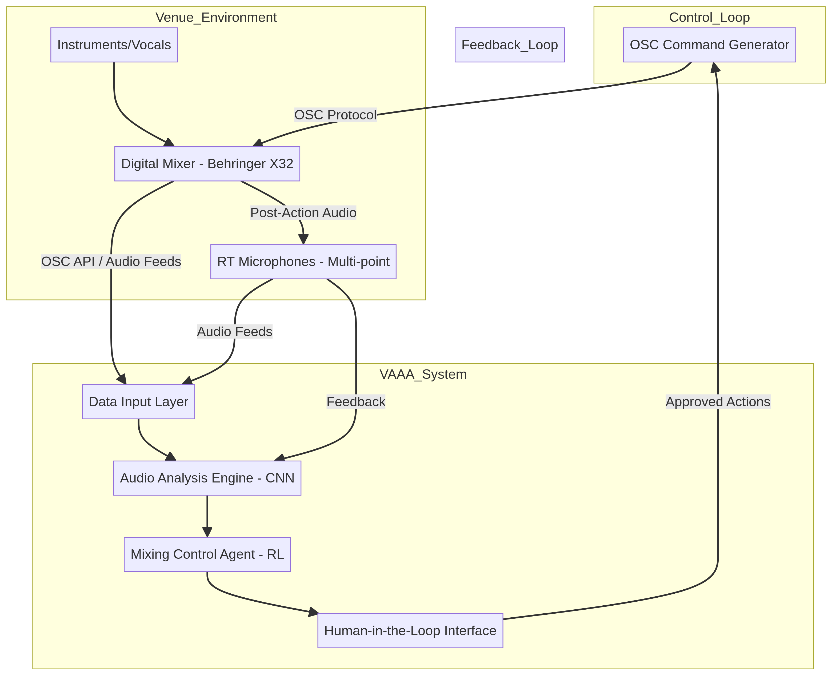
Figure 1: Conceptual Architecture of the Venue-Aware AI Assistant (VAAA)

4.3 Data Inputs & Sources
The VAAA relies on a multimodal data input strategy. Unstructured audio data is captured from two primary sources: direct audio feeds from the digital mixer (pre- and post-fader for each channel) and a network of strategically placed real-time (RT) microphones throughout the venue. These microphones provide crucial acoustic feedback from various audience perspectives, capturing room impulse responses, reverberation characteristics, and potential feedback frequencies. Structured data is obtained via the Behringer X32’s Open Sound Control (OSC) API, providing real-time mixer state information (e.g., fader positions, EQ settings, compressor parameters). Additionally, metadata such as venue dimensions, audience capacity, and genre-specific mixing preferences can be manually input. Data quality challenges include microphone placement optimization, ambient noise filtering, and ensuring precise synchronization across all audio streams. Basic preprocessing will involve noise reduction, gain normalization, and time-alignment of audio signals, alongside parsing and validation of OSC data.

4.4 Knowledge Representation & Modelling Approach
The VAAA employs a hybrid knowledge representation and modelling approach. The Audio Analysis Engine utilizes deep learning, specifically Convolutional Neural Networks (CNNs), to learn intricate patterns from raw audio. CNNs are adept at feature representation, transforming raw waveforms into meaningful embeddings that capture spectral, temporal, and spatial characteristics of sound. This allows for robust instrument identification, vocal separation, and acoustic anomaly detection. The Mixing Control Agent then leverages a Reinforcement Learning (RL) framework. In this model, the state is represented by the features extracted by the CNNs combined with the current mixer settings (from OSC data). The actions are discrete or continuous adjustments to mixer parameters (e.g., fader levels, EQ bands, compressor ratios). The RL agent learns an optimal policy through trial and error, guided by a reward function that quantifies audio quality and engineer feedback. This hybrid architecture combines the powerful perceptual capabilities of deep learning with the adaptive decision-making of reinforcement learning, suitable for the dynamic nature of live sound.

4.5 Decision-Making Logic / Learning / Inference
The VAAA's decision-making logic is centered around the Reinforcement Learning (RL) agent. During training, the RL agent interacts with a simulated live sound environment, receiving observations (audio features, mixer state) and taking actions (mixer adjustments). A reward function, designed to reflect objective audio quality (e.g., clarity, balance) and potentially incorporate human preferences, guides the learning process. The agent's policy, which maps states to actions, is continuously refined to maximize cumulative reward. In deployment (inference), the trained RL agent receives real-time observations from the Audio Analysis Engine and the mixer. It then infers the optimal actions based on its learned policy. A crucial component is the Human-in-the-Loop (HITL) mechanism. The AI's proposed actions are presented to the sound engineer via a graphical interface. The engineer can accept, modify, or reject these suggestions, providing implicit feedback that can be used for further model refinement or adaptation. This iterative process ensures that the AI acts as an intelligent assistant, not an autonomous replacement.

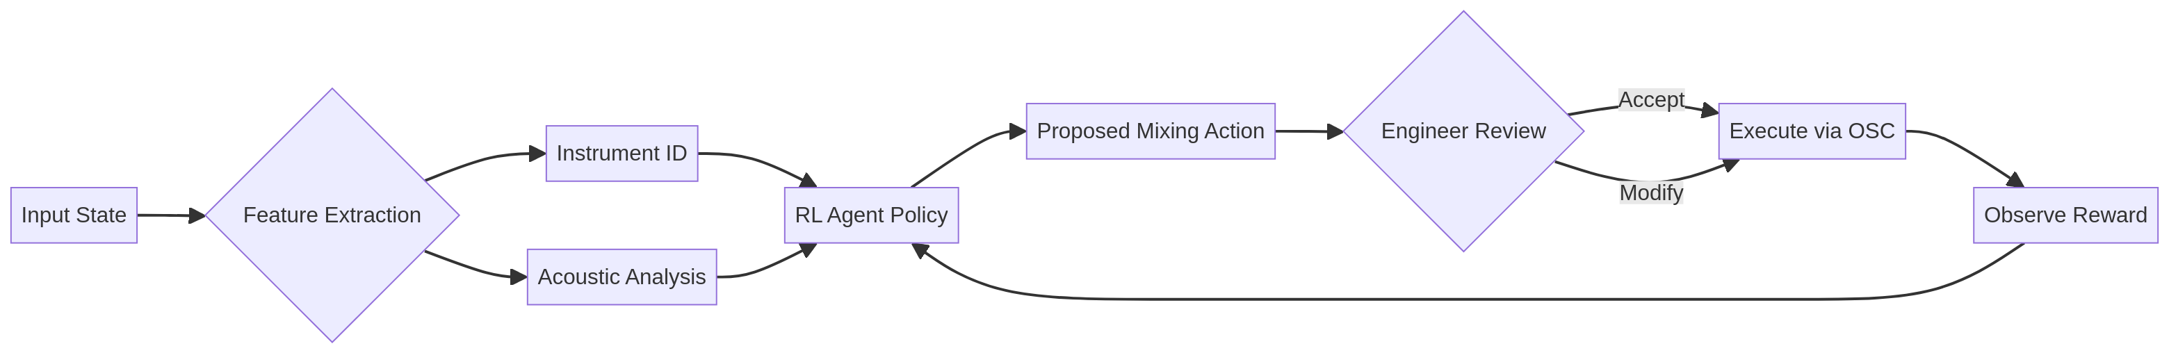
Figure 2: Decision-Making Logic and Feedback Loop

4.6 Evaluation Plan & Metrics
Evaluating the VAAA will involve both objective and subjective metrics. Technical metrics will include Signal-to-Noise Ratio (SNR), Total Harmonic Distortion (THD), and frequency response flatness, measured at various points in the venue. Latency will be rigorously tested to ensure real-time performance, targeting sub-10ms. Robustness and generalization testing will involve deploying the VAAA in diverse venues with varying acoustic properties and musical genres. Fairness metrics will assess whether the AI’s mixing decisions inadvertently favor certain instruments or vocal types, ensuring a balanced mix across all sources. Explainability will be addressed through visualization tools in the HITL interface, allowing engineers to understand the AI’s reasoning behind proposed adjustments, fostering trust and facilitating debugging.

5. Ethical & Societal Reflection

5.1 Key Risks
The deployment of a Venue-Aware AI Assistant (VAAA) in live sound engineering presents several ethical and societal risks. Firstly, there is a significant concern regarding job displacement for human sound engineers. While intended as an assistant, an overly capable or poorly integrated AI could devalue the engineer's role, leading to reduced employment opportunities or downward pressure on wages. Secondly, the potential for algorithmic bias in what constitutes a "good" mix is substantial. If the VAAA is trained predominantly on data from specific genres or cultural contexts, it might inadvertently perpetuate or amplify certain aesthetic preferences, leading to a homogenization of live sound and marginalizing diverse musical expressions. Thirdly, the extensive use of real-time microphones throughout a venue raises privacy concerns. Audio data, even if intended for acoustic analysis, could potentially capture conversations or identify individuals, leading to surveillance anxieties and misuse if not properly secured and anonymized. Lastly, over-reliance and deskilling of engineers could occur, where critical listening and problem-solving skills diminish due to constant AI assistance, making engineers less capable in situations where AI fails or is unavailable.

5.2 Mitigations & Best Practices
To address these risks, several mitigation strategies and best practices must be integrated into the VAAA's design and deployment. Human oversight and control are paramount; the VAAA must always function as an assistant, with the engineer retaining ultimate decision-making authority (Human-in-the-Loop design). This prevents deskilling and ensures artistic intent is preserved. For algorithmic bias, training datasets must be diverse, encompassing a wide range of musical genres, acoustic environments, and mixing styles. Regular bias audits and monitoring of the AI's output are essential to identify and correct any emerging biases. Regarding data governance and privacy, strict protocols for audio data collection, storage, and processing are required. All captured audio should be anonymized, encrypted, and used solely for acoustic optimization, with clear consent mechanisms for data usage. Furthermore, transparency and documentation of the AI's decision-making processes, perhaps through explainable AI (XAI) techniques, can build trust and allow engineers to understand and challenge the AI's suggestions. Finally, deployment safeguards such as fail-safe modes and clear protocols for manual override are crucial to prevent catastrophic failures during live events.

6. Conclusion
The challenges inherent in live sound mixing, characterized by high cognitive load on engineers and dynamic venue acoustics, significantly impact the quality of audience experience. This report has presented the Venue-Aware AI Assistant (VAAA) as a conceptual solution to these persistent industry problems. By integrating real-time multi-point acoustic data with advanced AI techniques like deep learning and reinforcement learning, the VAAA aims to provide intelligent, adaptive assistance to sound engineers. This approach directly addresses critical research gaps in holistic, real-time, venue-aware mixing systems. While acknowledging ethical considerations such as job displacement and algorithmic bias, the VAAA, with its human-in-the-loop design and robust mitigation strategies, promises to elevate live sound quality, reduce operational burdens, and unlock new creative possibilities for the future of live music.

References
[1] S. Compton, "Live-Sound Pressure That Is Not Measured In Decibels: An investigation into live-sound culture and the interpersonal pressures that influence audio engineer choice, the live-sound “experience,” and the health and wellbeing of participants," International Journal of Applied Positive Psychology, vol. 9, pp. 71–100, 2024. [Online]. Available: https://link.springer.com/article/10.1007/s41042-023-00112-7

[2] M. Terrell and M. Sandler, "An Offline, Automatic Mixing Method for Live Music, Incorporating Multiple Sources, Loudspeakers, and Room Effects," Computer Music Journal, vol. 36, no. 2, pp. 37–54, 2012. [Online]. Available: https://ieeexplore.ieee.org/abstract/document/6791175/

[3] D. Koszewski, "Automatic music signal mixing system based on one-dimensional convolutional neural networks," EURASIP Journal on Audio, Speech, and Music Processing, vol. 2023, no. 1, pp. 1-14, 2023. [Online]. Available: https://link.springer.com/article/10.1186/s13636-022-00266-3

[4] A. Tsiros, "Towards a Human-Centric Design Framework for AI-powered Music Production Interfaces," in Proceedings of the International Conference on New Interfaces for Musical Expression, 2020, pp. 78-83. [Online]. Available: https://www.nime.org/proceedings/2020/nime2020_paper78.pdf

[5] R. Zaheer, I. Ahmad, D. Habibi, and K. Y. Islam, "A survey on artificial intelligence-based acoustic source identification," IEEE Access, vol. 11, pp. 53969-53992, 2023. [Online]. Available: https://ieeexplore.ieee.org/abstract/document/10146285/

[6] S. Gul and M. S. Khan, "A survey of audio enhancement algorithms for music, speech, bioacoustics, biomedical, industrial, and environmental sounds by image U-Net," IEEE Access, vol. 11, pp. 140298-140324, 2023. [Online]. Available: https://ieeexplore.ieee.org/abstract/document/10371226/

[7] L. F. Fermin, "AI Driven Multitrack Audio Mixing Using Fuzzy Logic Tools," Ph.D. dissertation, New York University, 2020. [Online]. Available: https://search.proquest.com/openview/d6998d9a9c4f924b3ca6281cf55b3696/1

[8] W. Ma, et al., "Applications of Artificial Intelligence in Music: A Review," International Journal of Creative Computing, vol. 1, no. 1, pp. 1-20, 2025. [Online]. Available: https://www.sciopen.com/article/10.26599/IJCS.2025.9100011

[9] C. Fernandez, et al., "Virtual Acoustic Environment Rehearsal and Performance System," Applied Sciences, vol. 15, no. 3, p. 35, 2025. [Online]. Available: https://www.mdpi.com/2813-2084/4/3/35

[10] L. Moysis, et al., "Deep Learning Methods for Music Signal Processing," IEEE Signal Processing Magazine, vol. 40, no. 1, pp. 46-61, 2023. [Online]. Available: https://ieeexplore.ieee.org/iel7/6287639/6514899/10043650.pdf

